Urban Ecosystem-based Adaptation for Climate-resilient Development in the Kathmandu Valley, Nepal

Event Completion Report
A Formal Opening Program to Initiate the Protection and Conservation work at
Hattichowk Open Space Ecosystem.

Venue: Tokha Municipality-6, Hattichowk
Date: 10th December 2025



Prepared By:
Project Management Unit
Urban EbA

Output 3.3 Flood management, erosion control and groundwater recharge measures in 5 vulnerable public spaces in 5 municipalities across 3 districts.

A Formal Opening Program to Initiate the Protection and Conservation work at Hattichowk Open Space Ecosystem

Initiated by Urban Ecosystem-based Adaptation for Climate Resilient Development in The Kathmandu Valley, Nepal and implemented by KVDA, the activity Restoration and Protection of Urban Space Ecosystem, Gale Ward-2 and Hattichowk Ward-6, Tokha Municipality, aims to protect and conserve urban ecosystems to enable the services such as flood control, landslide management, groundwater recharge and urban cooling. It is well-known that heat waves, storms, and rains are becoming more often and intense due to climate change. These extreme weather events affect our cities and towns, and they also negatively influence flora and open spaces, making them less robust to future consequences. Parks and open spaces are therefore vital components of the city.

On 10th December 2025, the ward chair of Tokha-6 headed over a foundation stone-laying ceremony for the site Restoration and Protection of Urban Space Ecosystem, Gale Ward-2 and Hattichowk Ward-6, Tokha Municipality, which was jointly inaugurated by the mayor of Tokha Municipality and the Development Commissioner of the Kathmandu Valley Development Authority. Along with the ward members of Tokha-6, representatives of the Urban EbA team participated in the occasion.

To sum up the ceremony, the Mayor gave statements, highlighting the significance of this initiative in Tokha Municipality for the advancement and development of individuals and the community. Additionally, he added that this project would assist water management in surrounding regions via recharge ponds and a ground water recharge system, as well as help to naturally cool air surfaces.

Attendees
S.N | Name | Designation
1 | Shanta Khanal | Ward Chair
2 | Januka Dhakal | DC, KVDA
3 | Prakash Adhikari | Mayor, Tokha Municipality
4 | Murari Tamang | Deputy Mayor, Tokha Municipality
5 | Kamal Bhattarai | Admin Officer
6 | Prakrina Tuladhar | National Project Director, UEbA
7 | Durga Prasad Upadhyay | National Project Manager, Urban EbA
8 | Saurab Dhakal | Engineer, KVDA
9 | Uday Kumar Pokharel | Engineer, UEbA
10 | Birendra Kumar Pun Magar | Admin Officer, UEbA
11 | Keshab Prasad Neupane
12 | Sunita Pariyar | Head of Health Organization
13 | Birendra Kumar Pun Magar | Admin Officer, UEbA
14 | Krishna Aryal
15 | Ambika Acharya
16 | Basudev Bogati
17 | Dambar Bahadur Thapa
18 | Lalu Prasad Subedi
19 | Shiva Prasad Upadhyay
20 | Durga Prasad Niraula
21 | Pawan Kumar Shah
22 | Pawan Basnet
23 | Krishna Paudel
24 | Shambu Ram Khatri
25 | Dhaneshwar Pathi
26 | Prakash Bhandari
27 | Manoj Thapa
28 | Tarapati Paudel
29 | Bishnu Subedi
30 | Rajesh Shrestha
31 | Rabindra Paudel
32 | Birendra Lamichhane
33 | Indra Prasad Adhikari
34 | Bharat Paudel
35 | Japkrishna Paudel
36 | Durga Bahadur Pradhan
37 | Trilochan Chalise
38 | Gopal Dhungana
39 | Gyan Prasad Parajuli
40 | Keshab Prasad Neupane
41 | Rishiram Aryal
42 | Dilip Kumar Mathema
43 | Narmada Paudel
44 | Laxmi Shrestha
45 | Ambika Paudel
46 | Kamala Giri
47 | Bishnu Aryal

Attachments
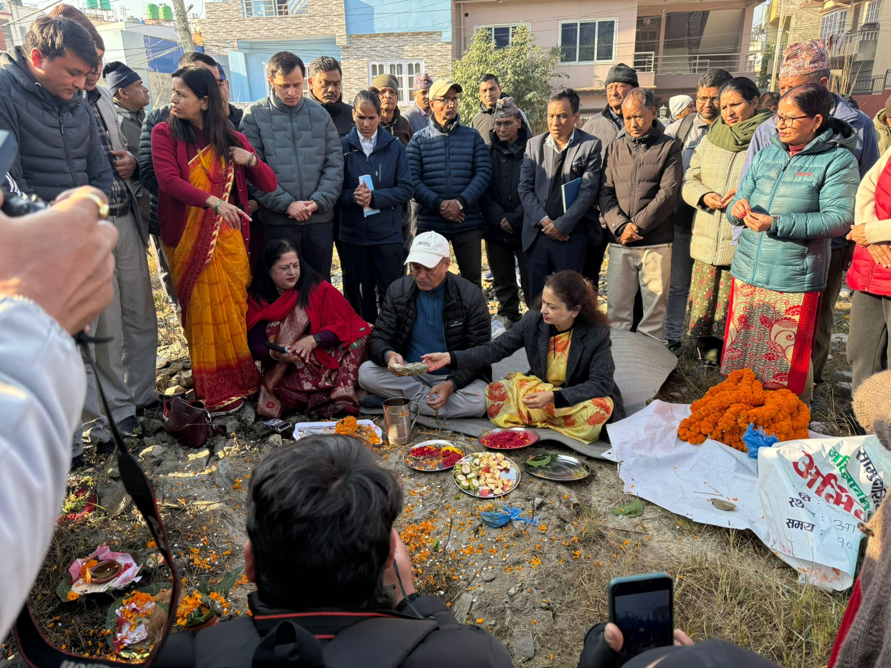
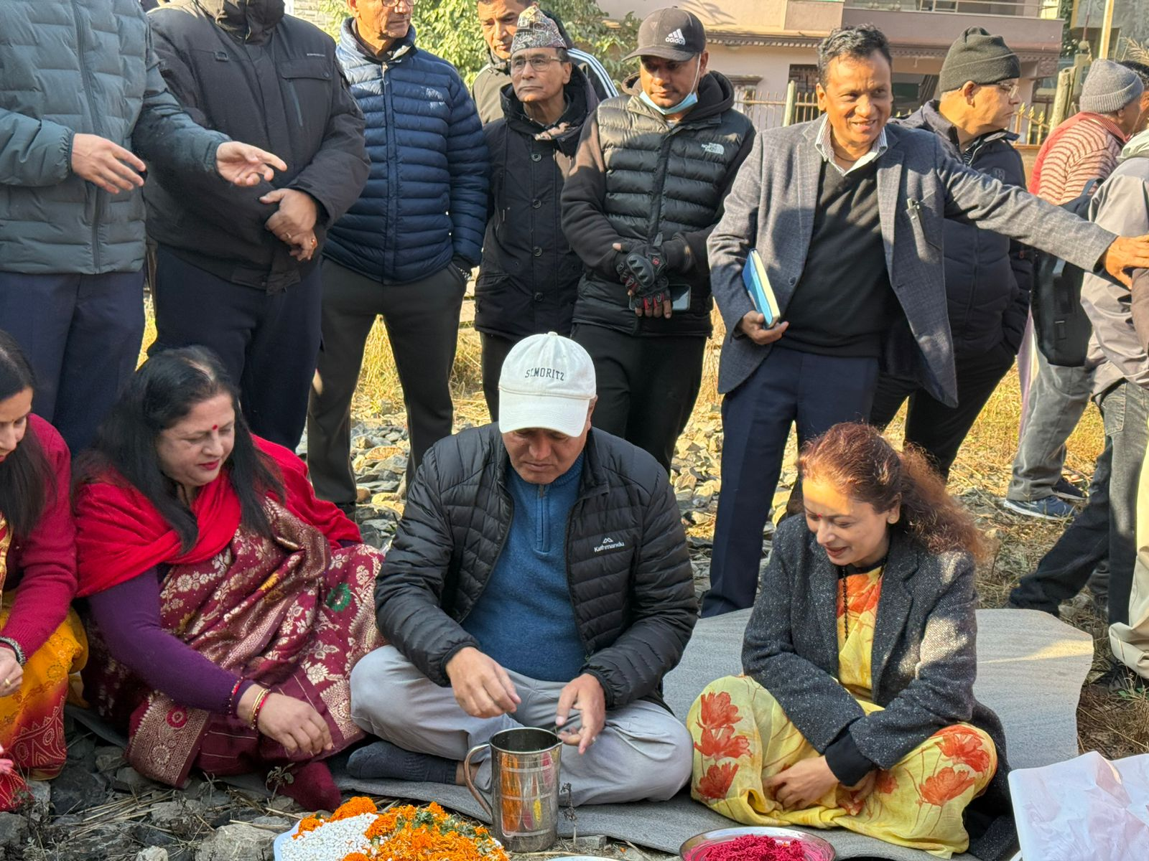

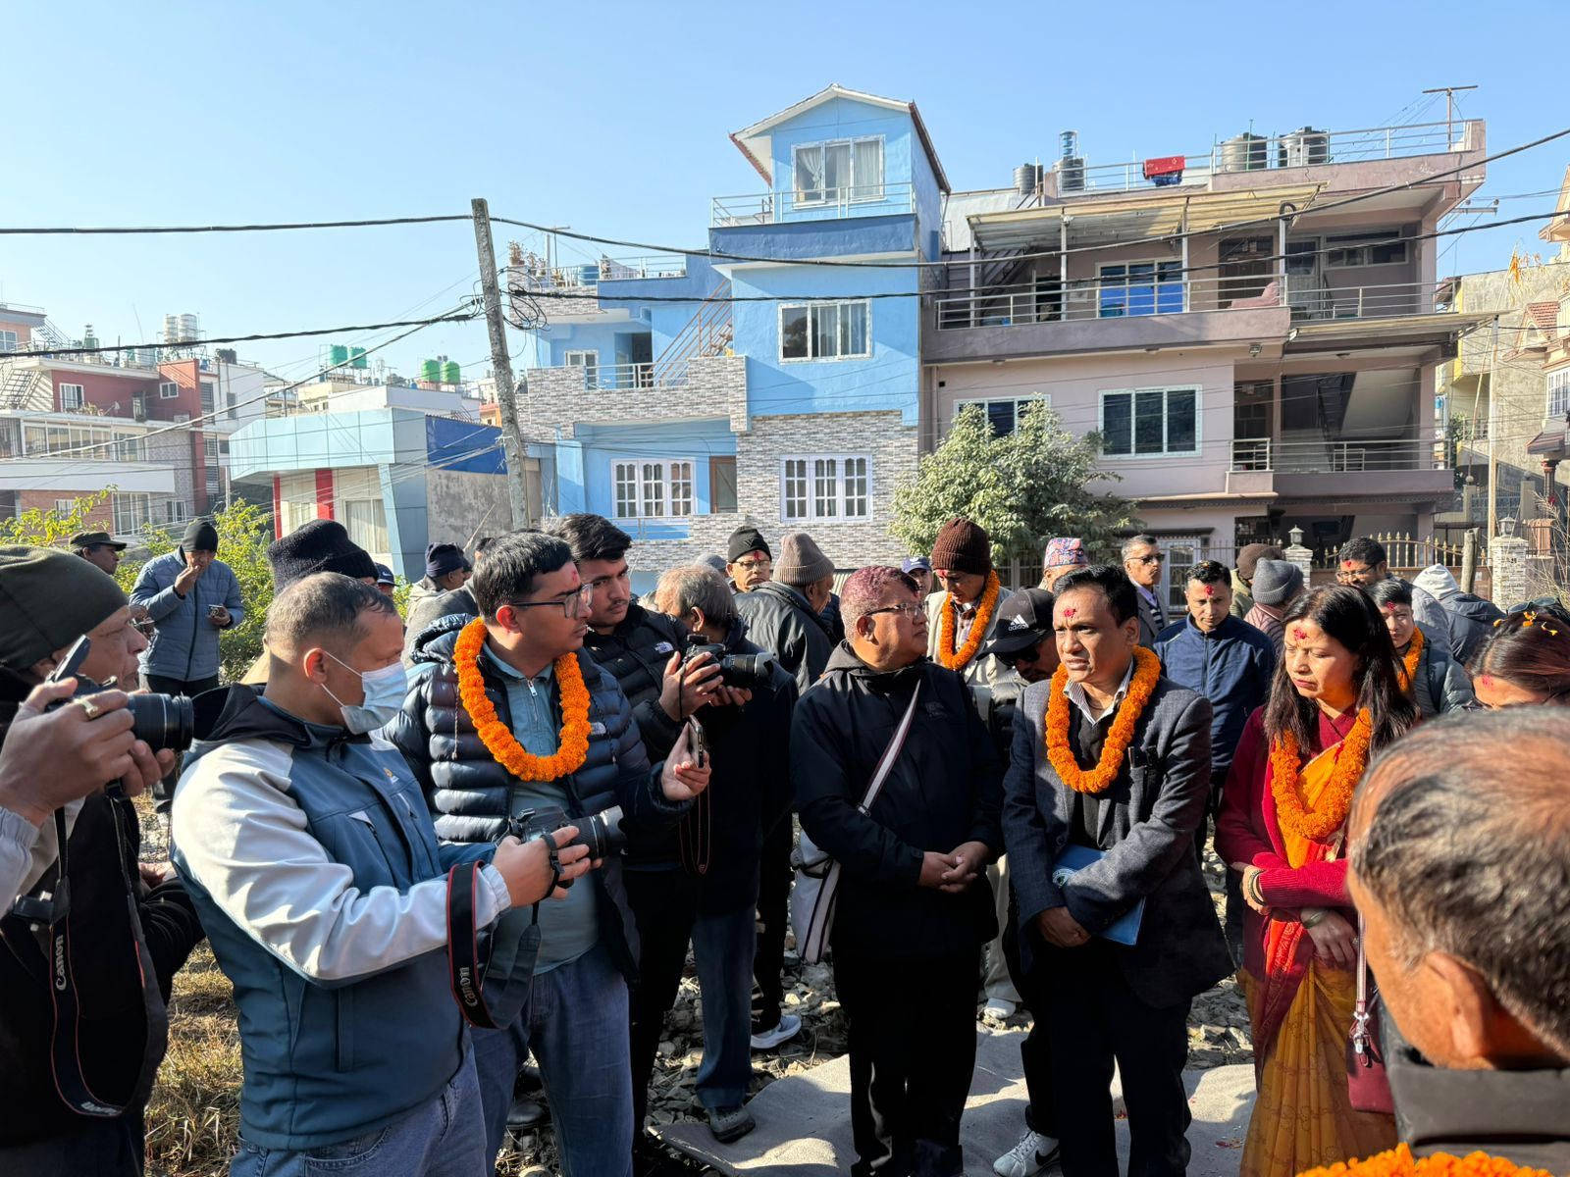

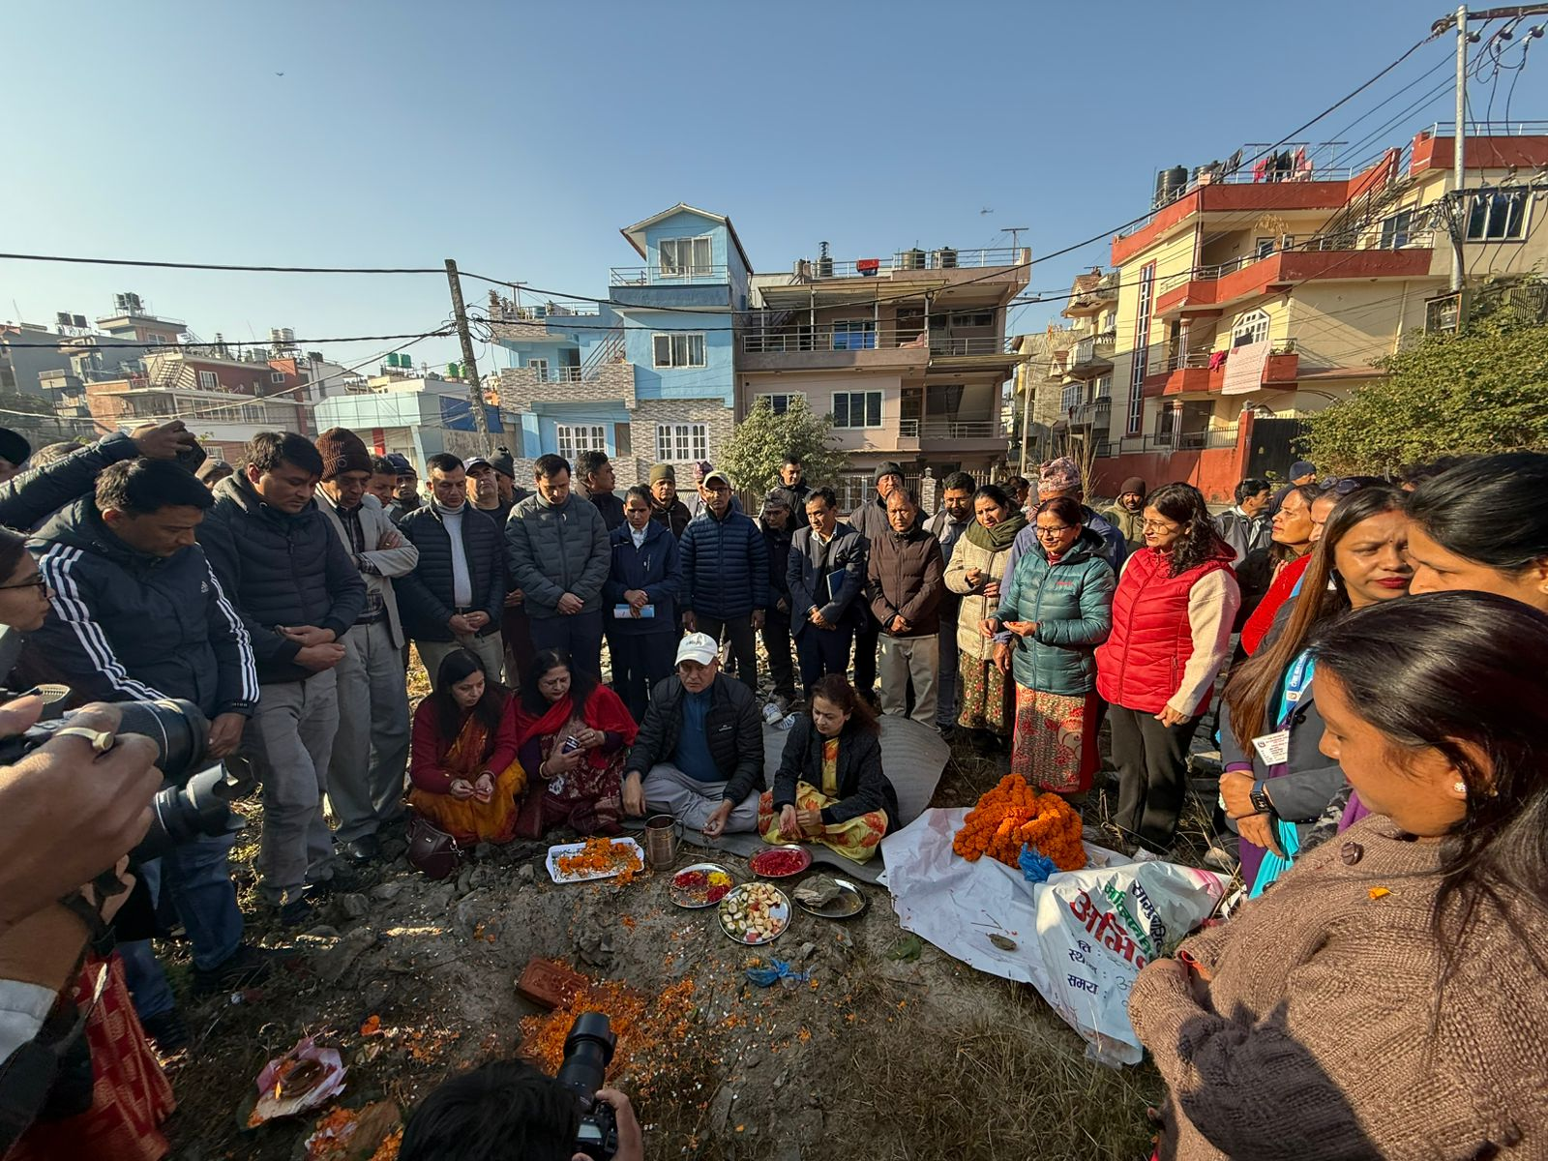

Reviewed By: Approved By:

SIGNATURE _________________ SIGNATURE _________________
Name: Mr. Durga Prasad Upadhyay Name: Mr. Prakrina Tuladhar
National Project Manager National Project Director
Urban EbA Urban EbA

